RECALL: 3 kinds of accumulators

1. Context-preserving accumulators
   * Preserve context lost in natural recursion
2. Result-so-far accumulators
   * Help achieve tail recursion by eliminating the need for pending operations
3. Worklist accumulators
   * Help achieve tail recursion by eliminating the need to retain future recursive calls in pending operations

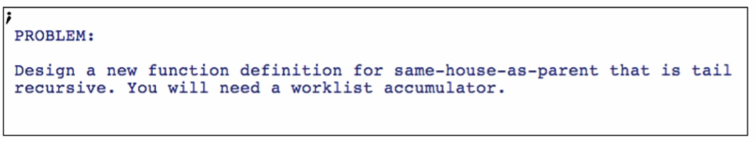

Redoing the function only: Comment out the old one first!

**Planning**

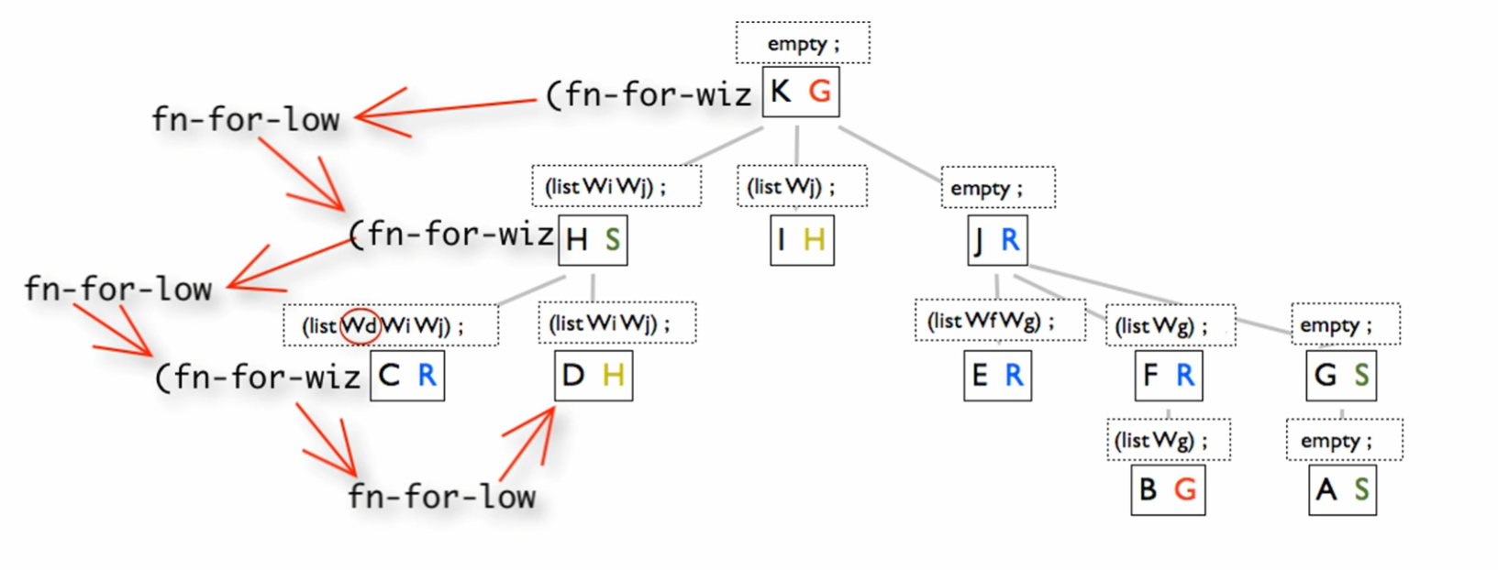

Order of the traversal/function calls

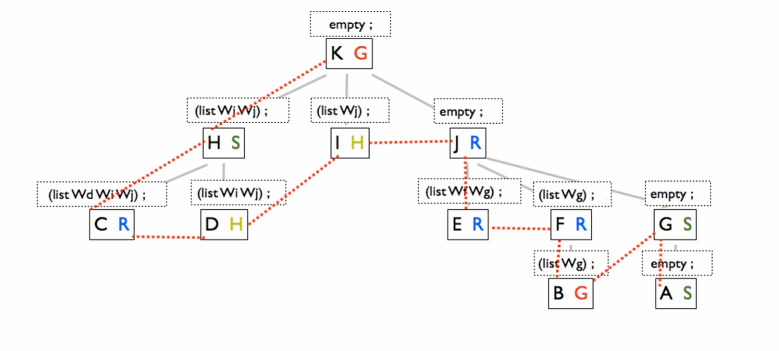8



Because of this, if we will only use “worklist” accumulators not lost context accumulator, the worklist needs to include the parent house of each wizard on the worklist. Eg:

* (list Wh Wi Wj) must be
* (list
  + Wh – with parent house G
  + Wi – with parent house G
  + Wj – with parent house G

Like this:

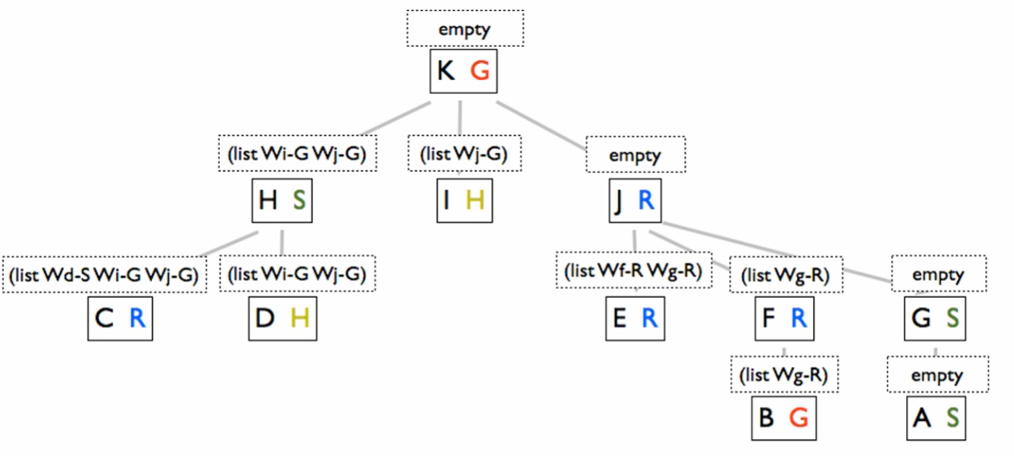

Each entry on our worklist accumulator includes

* Wizard to visit
* Wizard’s parent house – the context accumulator is being incorporated the worklist accumulator